**HTML5 New Form Field Attributes**

**HTML5 added the following attributes for <input>:**

* autocomplete
* autofocus
* form
* formaction
* formenctype
* formmethod
* formnovalidate
* formtarget
* height and width
* list
* min and max
* multiple
* pattern (regexp)
* placeholder
* required
* step

1. **Attribute = Required**

The required attribute specifies that an input field must be filled out before submitting the form.

The required attribute works with the following input types: text, search, url, tel, email, password, date pickers, number, checkbox, radio, and file.

**Example:**

**Username: <input type="text" name="username" required>**

**Output:**

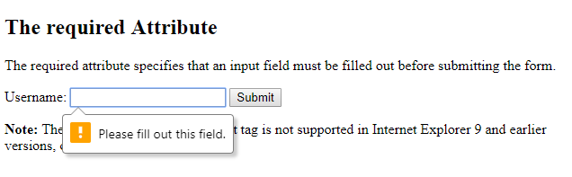

*The form will not be submitted if the fields are not filled.*

**Placeholder**

The placeholder attribute specifies a hint that describes the expected value of an input field (a sample value or a short description of the format).

The hint is displayed in the input field before the user enters a value.

The placeholder attribute works with the following input types: text, search, url, tel, email, and password.

**Example:**

**<input type="text" name="fname" placeholder="First name">**

**Output:**

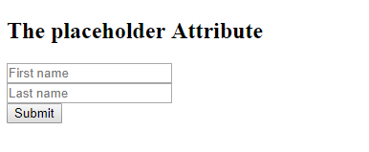

*Note: The placeholder attribute of the input tag is not supported in Internet Explorer 9 and earlier versions.*

**Attribute = autofocus**

The autofocus attribute specifies that the input field should automatically get focus when the page loads.

**Example:**

**First name:<input type="text" name="fname" autofocus>**

**Output:**



The First name will get focussed once the page get loaded

**Pattern**

The pattern attribute specifies a regular expression that the <input> element's value is checked against.

The pattern attribute works with the following input types: text, search, url, tel, email, and password.

Tip: Use the global title attribute to describe the pattern to help the user.

**Example:**

**Country code: <input type="text" name="country_code" pattern="[A-Za-z]{3}" title="Three letter country code">**

**Output:**

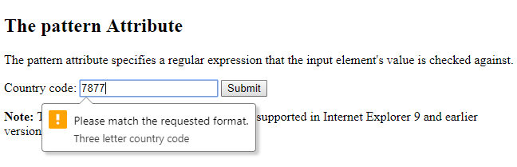

***Note: The pattern attribute of the input tag is not supported in Internet Explorer 9 and earlier versions, or in Safari 10 and earlier versions.***

**Reference**

1. **https://www.w3schools.com/html/html_form_attributes.asp**